Overview

The Final Assessment has **three parts** and builds on your knowledge to create websites and simple front-end web applications. Specifically, you will be asked to do the following:

1. Design and create a personal website with information about yourself, your interests, and your expertise (worth 8%)
2. Research and implement a simple front-end (AJAX) application to access remote JSON data and render It on a Web Page (worth 7%)
3. Research and implement a static hosting solution for your final code, so that it can be viewed online (worth 5%)

Due Date

The Final Assessment is due on **Monday August 15th by midnight**. Please see Submission instructions at the end of this document. You **may** consult your notes and use the web, but you **may not** discuss any part of this final assessment with other students. All work must be your own.

Part 1. Website Design (8%)

You are asked to create a personal website to show off your skills as a web developer to possible employers. You are responsible for researching and implementing all aspects of this on your own.

Your website will be expected to have the following structure:

* All website content should be centered in the viewport, having equal margins on left and right. The page content should cover 90% of the viewport width (the width of the browser window). However, the content width should be limited to 1100 pixels, never growing larger than that (take a look at max-width css property).
* All web pages should be in the same theme, that mean the headers, navigation/menu bars, footers in all pages must look the same.
* The menu bar should contain at least 3 menu items: "Home", "Interests", "Expertise". You can add more item(s), such as "Resume", "education" and so on if you want. This means your website should have at least 3 web pages. You must provide meaningful content for each page.
* You should make one page to contain 2 horizontal sections (e.g. main and aside) and another page to contain 3 sections. When the browser window is narrowed down horizontally, these sections should change from horizontal ones to vertical ones.
* In any page of your website, there should be one html table, one nested order or unorder list, one video player with a google video, one place where [Google Fonts](https://fonts.google.com/) is applied to the text.
* In any web page, add an html form to collect messages/comments from the website’s visitors. You must ensure the form’s "Full Name”, "Message" and “Email" fields are required for submitting the form. Your form should also contain more fields which are optional for submitting the form: "Phone", "Company", "Occupation", "Address". If the "Phone" field is provided, it must be in the format "(999) 999-9999". This form must submit to https://httpbin.org/post using the post method. JavaScript is required for the validation, and appropriate error message must show up for invalid fields. Also, CSS code is required for styling the html form.

Part 2. Create a simple front-end (AJAX) application to fetch JSON array data from remote web service and render the array data in a web page with CSS cards (7%)

1. Create a JavaScript (.js) file in your web project and embed the JavaScript file into your "Expertise" web page. Then use the AJAX technologies discussed in class to fetch data from the remote web service (url: <https://reqres.in/api/users?page=1>) when web page is successfully loaded into the browser. Use the statement "console.log('The fetched data', data);" to output the fetched data to web console as a proof that you have successfully fetched data from the web service. Also, it allows you to study the data structure of the fetched JSON array.
2. Research CSS Cards from this link <https://developer.mozilla.org/en-US/docs/Web/CSS/Layout_cookbook/Card>, then use this CSS Cards approach (or the gallery discussed in class or previous assignment) to render the fetched JSON array at the end of your "Expertise" web page as a showcase of your Expertise:

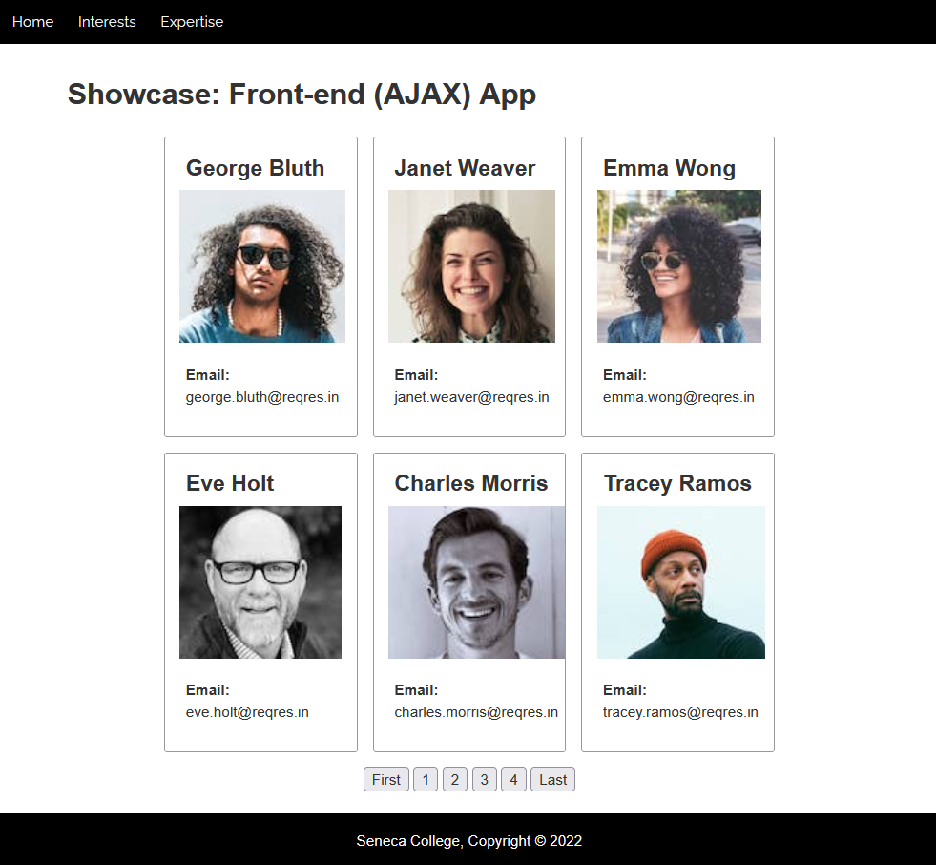 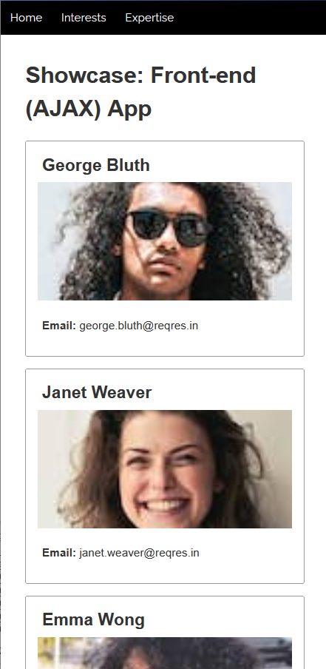

(Desktop screen) (mobile)

Part 3. Static Hosting (5%)

You are asked to research and implement a static hosting solution for your final assignment. Your final assignment, including your responsive design, should be accessible via a public URL. You do not need to spend any money to achieve this, since many free hosting services exist:

1. Netlify - <https://www.netlify.com/>
2. Zeit <https://zeit.co/>
3. GitHub Pages - <https://pages.github.com/>
4. Firebase - <https://firebase.google.com/docs/hosting>

Please submit the public URL for your project. All pages, images, etc. must work and not return 404s or other errors.

Honesty Statement:

*I declare that my assessment is wholly my own work in accordance with Seneca Academic Policy. No part of this assessment has been copied manually or electronically from any other source (including web sites) except for the information supplied by the WEB222 instructors and / or made available in this assessment for my use. I also declare that no part of this assignment has been distributed to other students.*

Submission

1. Add above Honesty Statement with **you full name** into your Home page
2. Compress your project folder (with all project files and subfolders included) into a zip file named submission.zip and upload the zip file to Blackboard
3. Please also **include the URL** to the publicly hosted version of your project.